Dashboard - Warehouse relocation progress monitoring by date

**From:** Mary Antonette Santos, Mary Antonette Santos   
**Sent:** Friday, July 04, 2014 2:10 PM

Requirement: To monitor and update open relocation transfer order in a daily basis

Expected output (graph)

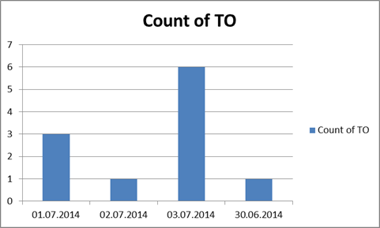

To Include completed TOs and Outstanding TOs

Attached raw data from the system for your reference.

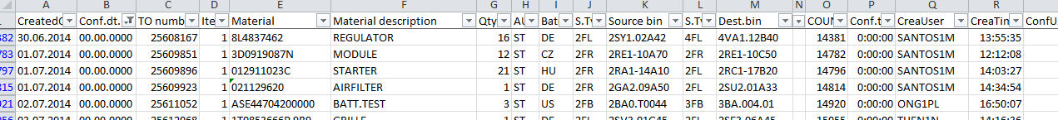

Data needed:

1. Conf.dt. (column B) – Confirmation date (00.00.0000) not confirmed
2. TO number (column C)

Update: expected information from the dashboard: (**Sent:** Wednesday, 09 July, 2014 3:31 PM)

1. Graph – showing total TO created (closed and pending TO to be closed)
2. Data – pls attached excel file for the information needed (highlighted in yellow)

|  |  |  |  |  |  |  |  |  |  |  |  |  |  |  |
| --- | --- | --- | --- | --- | --- | --- | --- | --- | --- | --- | --- | --- | --- | --- |
| CreatedOn | | Conf.dt. | | TO number | | | Item | Material | | Material description | | | | Qty |
|  | |  | |  | | |  |  | |  | | | |  |
| Batch | S.Typ | | Source bin | | S.Typ | Dest.bin | | | CreaUser | | ConfUser | MTy |
|  |  | |  | |  |  | | |

WMS changes:

Start Date: 2014.07.14 design

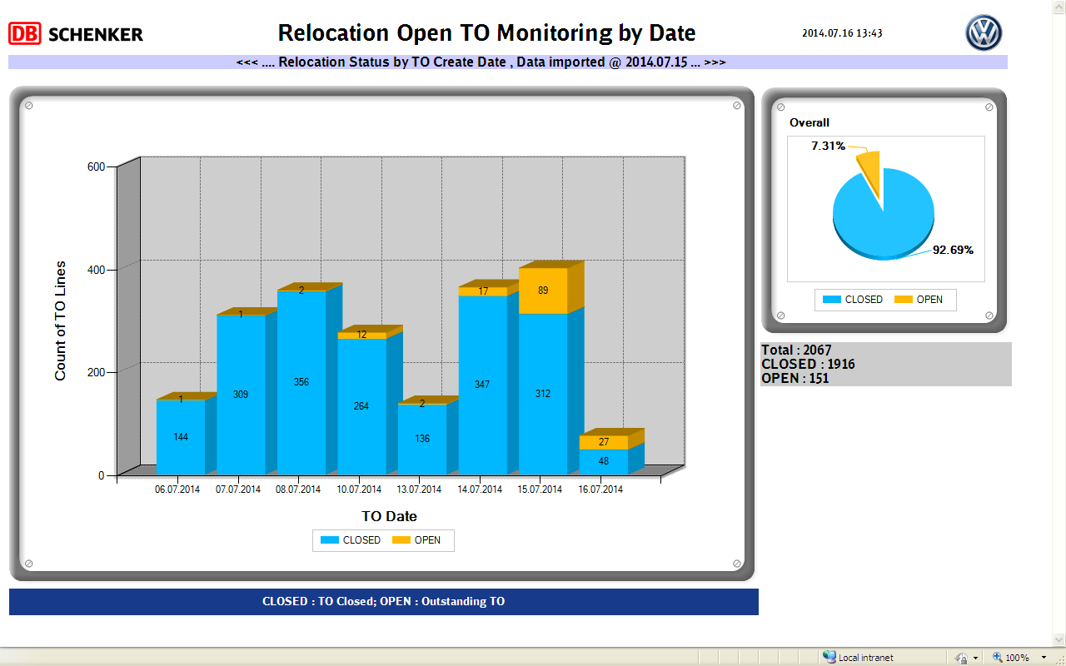

Tested:

**From:** Mary Antonette Santos, Mary Antonette Santos   
**Sent:** Thursday, 31 July, 2014 12:02 PM  
**To:** Chan, Pei-Fong  
**Cc:** sin.vw_whseplanning@dbschenker.com; Tan, khang-hwee  
**Subject:** RE: IMPORT ERROR - IMPORT_INRELOCATION - Update 31Jul

Hi Pei Fong,

Now the data is tally as verified.

Thanks for your usual support on this.

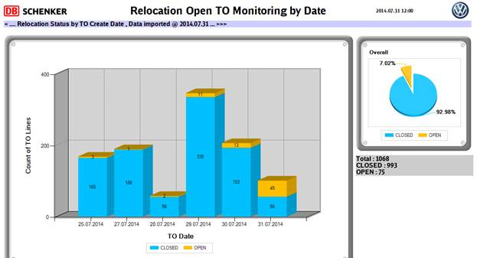

Regards,

Mary Santos (Ms)

Warehouse Planner

Contract Logistics/SCM, Operations

Schenker Singapore (Pte) Ltd

2 Changi South Avenue 1

Singapore 486149

DID: +65 6245 5324   Fax: +65 6545 7217

Mobile: +65 9001 8983